**Project Introduction: Analyzing Zomato Dataset for Insightful Restaurant Evaluation**

The fundamental purpose of this project is to delve into the intricacies of the Zomato dataset, unraveling the multifaceted factors that influence the aggregate rating of each restaurant. In a sprawling metropolis like Bengaluru, where gastronomic diversity thrives, the presence of over 12,000 restaurants catering to a wide array of global cuisines adds to the vibrant culinary landscape.

Bengaluru, often hailed as the IT capital of India, presents a unique dining scenario. The majority of its populace heavily relies on restaurant dining due to time constraints, resulting in an ever-increasing demand for culinary establishments. In this milieu, both new and established restaurants coexist, with many offering similar dishes. Consequently, the industry remains competitive, making it essential to gain a profound understanding of various demographic and culinary aspects.

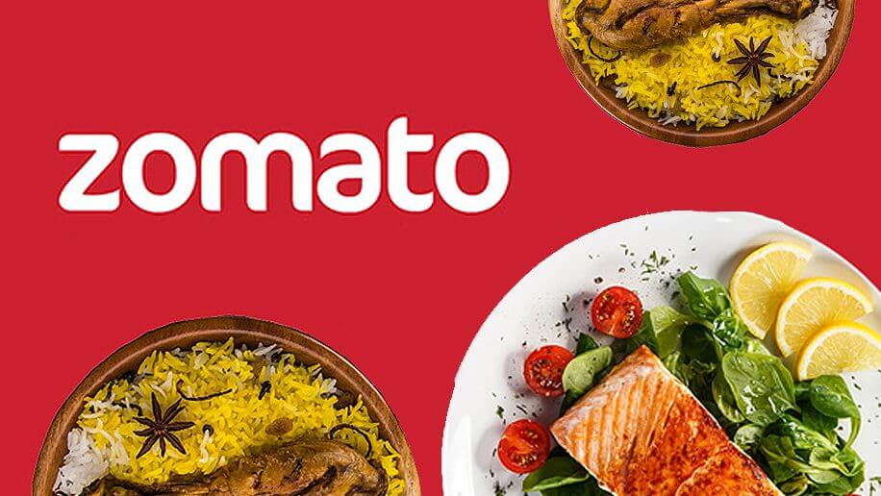

**Project Objectives:**

* Evaluate the factors contributing to the overall rating of restaurants.
* Investigate the diverse types of restaurants distributed across different locations in Bengaluru.
* Examine the preferences of localities, shedding light on popular food choices and dietary inclinations.
* . Evaluate the significance of major factors such as distinguishing between online and offline orders.
* Determine suitable locations for opening new restaurants, considering local demand and competition.
* Identify which restaurants offer table booking facilities and assess their availability.
* Investigate the preferences of customers regarding online or cash payments when placing food orders.
* Analyze the distribution of online order facilities based on location.
* Examine the availability of table booking facilities by location.
* Assess the relationship between restaurant types and their respective ratings.

By harnessing the power of data analysis, we aim to uncover the intricate relationships between these factors, ultimately providing valuable insights into the dynamic and evolving restaurant industry in Bengaluru. This analysis will aid not only the restaurant owners but also the broader community in making informed decisions related to dining preferences and choices.

**Assumptions**

* Customer behavior in the dataset is assumed to reflect real-world behavior.
* The variables in the dataset are assumed to be relevant to restaurant ratings.
* We assume there have been no major shifts in the local restaurant market.
* Data points are assumed to be independent of each other.
* Our analytical methods are assumed to be suitable for valid results.

**Hypothesis**

1. **Location vs. Ratings:**
   * Testing if the location of a restaurant affects its ratings.
2. **Online Ordering vs. Average Cost:**
   * Investigating if offering online ordering affects the average cost of dining.
3. **Type of Restaurant vs. Average Votes:**
   * Examining if the type of restaurant impacts the average number of votes received.
4. **Cuisine vs. Average Cost:**
   * Analyzing if different cuisines have different average costs.
5. **Location vs. Average Votes:**
   * Evaluating if the location of a restaurant influences the average number of votes received.
6. **Online Ordering vs. Ratings:**
   * Exploring if offering online ordering affects the ratings given to a restaurant.
7. **Restaurant Type vs. Ratings:**
   * Testing if the type of restaurant (e.g., Cafe, Pub, Buffet) has an impact on the ratings.

**Analysis and findings**

count plot of various Locations

Top of Form

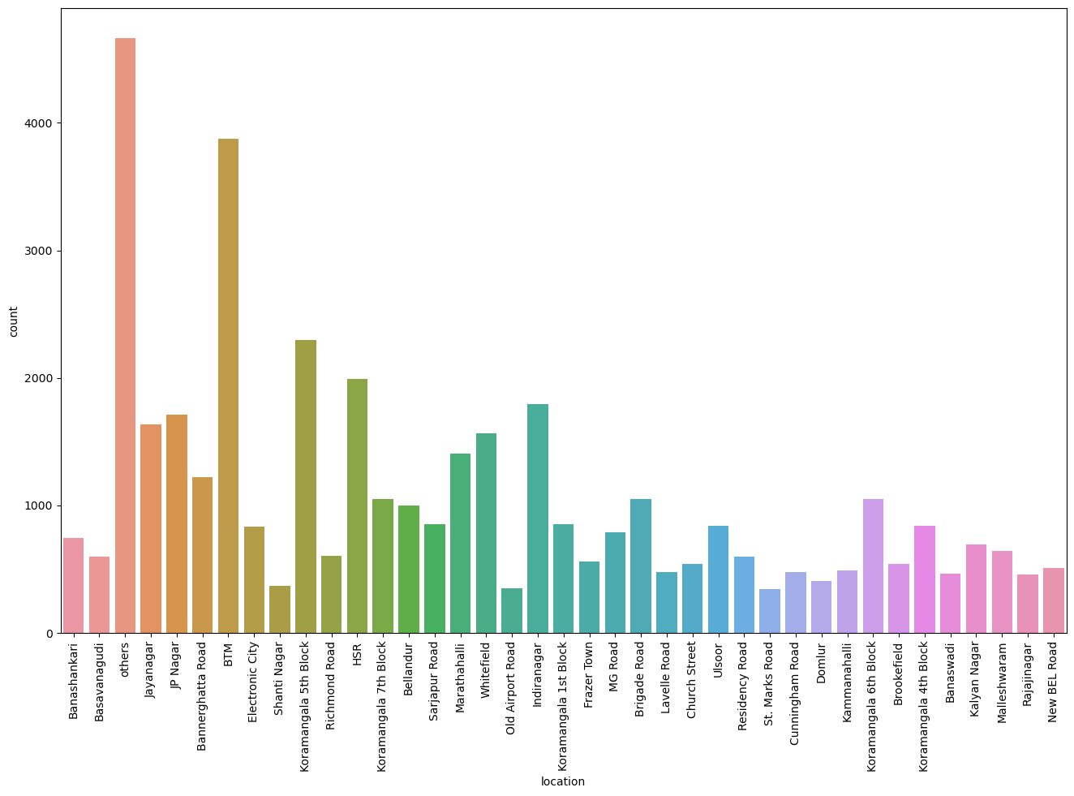Bottom of Form

The analysis suggests that opening a restaurant in BTM, which already has a high concentration of eateries, may not be the most favorable choice. Exploring locations with fewer restaurants, such as Old Airport Road, appears to offer untapped opportunities for a successful venture, ensuring less competition and potentially higher chances of business growth.

visualizing online order

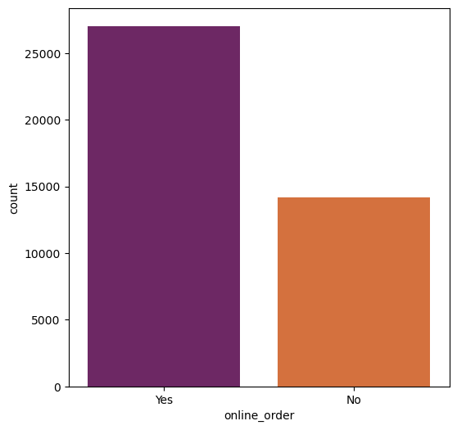

The majority of restaurants, around 30,000, offer online ordering services, while roughly 20,000 do not provide this convenience. It's evident that the demand for online ordering is substantial, and incorporating this service can be beneficial for restaurants seeking to cater to a broader customer base and adapt to modern dining preferences.

Visualizing Book Table,

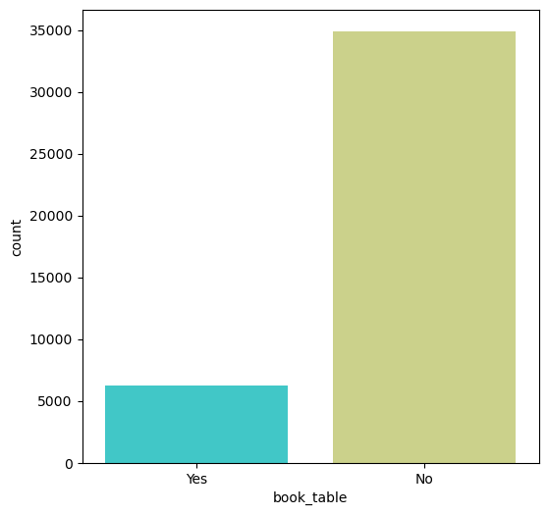

The data analysis reveals that a significant number of restaurants do not offer a table booking facility. This implies that most restaurants in the dataset operate on a first-come, first-served basis, which may be due to their style of service or the type of cuisine they offer. Restaurant owners considering the addition of table booking services should evaluate the demand for such a feature in their specific location and among their target customers.

Visualizing Online Order vs Rate

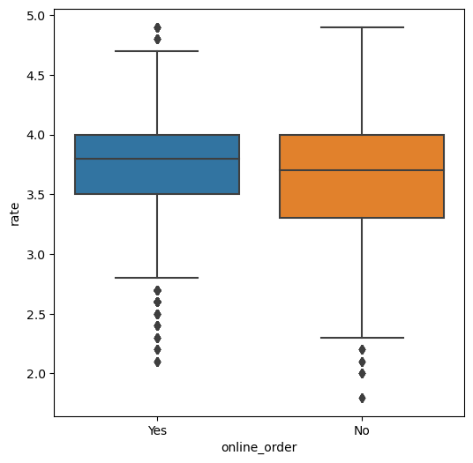

Restaurants offering online order facilities tend to have higher average ratings, with a median rating of 4.5, compared to restaurants without online order facilities, which have a median rating of 4.2. This suggests that online ordering may be associated with improved customer satisfaction and higher ratings based on feedback. It's important to note that the ratings here represent customer feedback scores, not the price of the food. Restaurant owners should consider incorporating online order services to potentially enhance their overall customer experience and ratings.

visualizing Book Table vs Rate

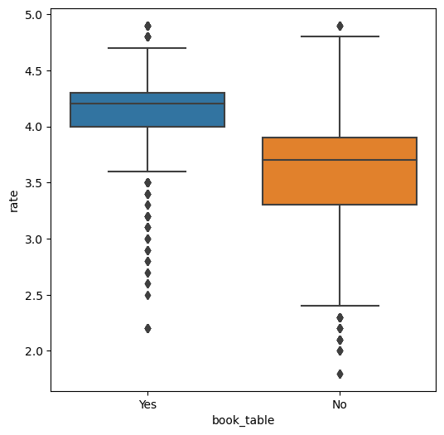

The analysis of restaurants with and without the book table facility reveals that restaurants offering the book table option tend to have higher average ratings. This suggests a positive correlation between providing a book table service and receiving higher customer ratings. Restaurant owners should consider offering a book table facility as it appears to contribute to higher customer satisfaction and better ratings. Providing this service may enhance the overall dining experience and potentially lead to improved customer feedback.

visualizing Online Order Facility,Location Wise

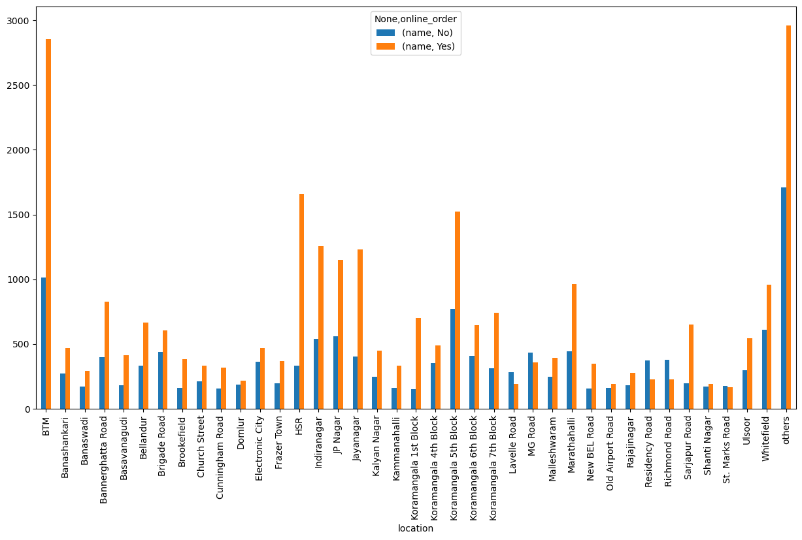

various locations and their online order facilities suggests that the BTM location has the highest number of restaurants offering online order services. In contrast, Lavelle Road has a smaller number of restaurants with no online order facility. This indicates an opportunity to open a restaurant in Lavelle Road, as there is less competition in terms of online food ordering services in this area. Expanding to such areas may provide a competitive advantage and tap into a market with fewer existing options.

visualizing Book Table Facility,Location Wise

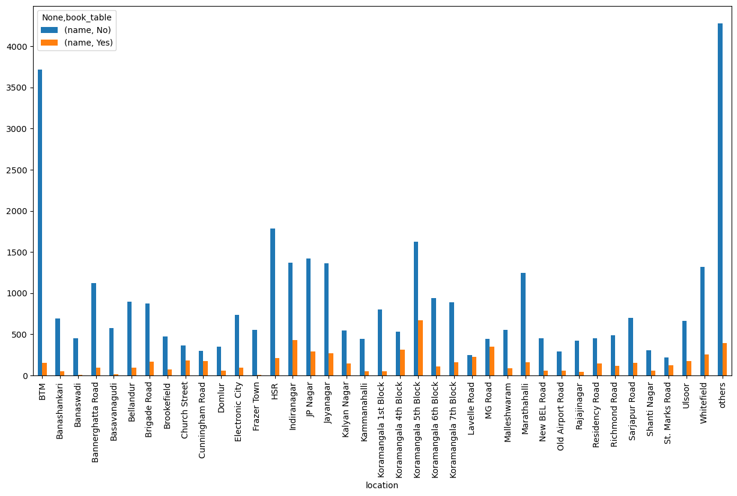

The barplot analysis of various locations and their book table facilities suggests that many restaurants in the BTM area do not provide a book table facility. Therefore, opening a restaurant with this feature in BTM may face high competition. On the other hand, HSR has a relatively lower number of restaurants offering book table services, indicating an opportunity for growth in this location. Thus, opening a restaurant with a book table facility in HSR may lead to a competitive advantage and business growth.

visualizing Types of Restaurents vs Rate

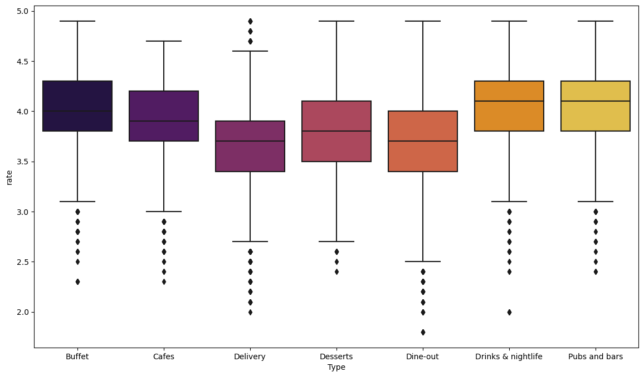

Restaurant types (Type) against the average rating (rate) indicates that "Drinks & nightlife" restaurants receive the highest average rating from customers, suggesting that people are highly satisfied with these types of establishments. On the other hand, "Delivery" restaurants tend to have lower ratings. Therefore, if you plan to open a restaurant, you should consider offering options related to "Pubs and bars" or "Drinks & nightlife" to cater to the preferences of customers who enjoy these types of dining experiences.

Grouping Types of Restaurents, location wise

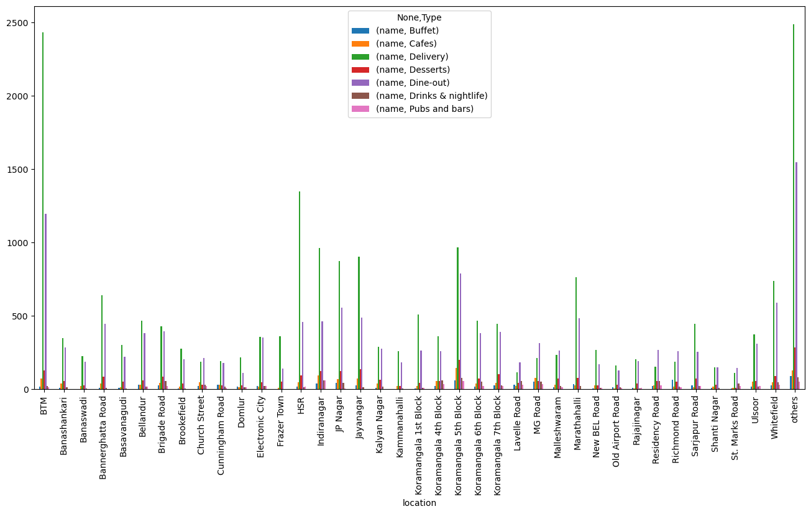

Restaurant locations against the presence of "Pubs and bars" indicates that in locations like Shivajinagar and Shantinagar, there are fewer restaurants with pubs and bars. If you plan to open a bar and pub, these locations might be promising, as there is relatively less competition in terms of the number of such restaurants

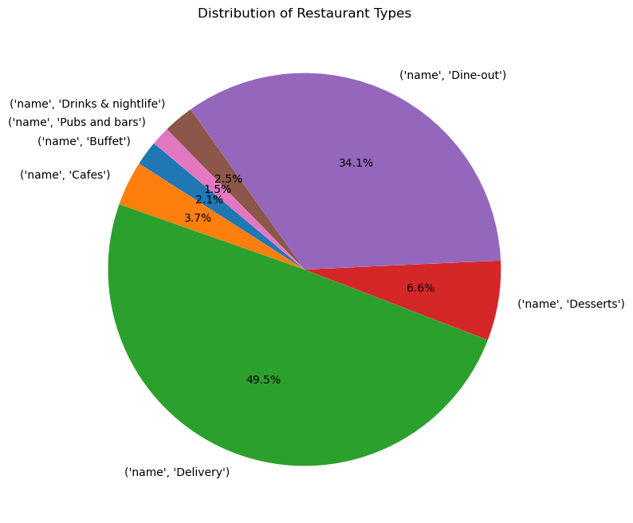

The pie chart clerly showen the position of restorent types

No. of Votes,Location Wise

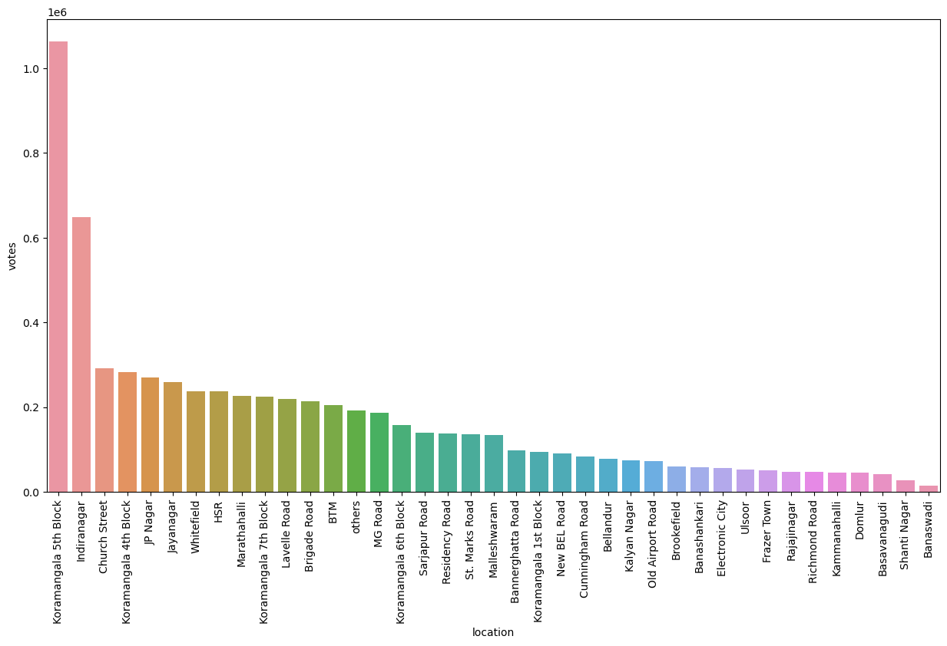

The analysis of votes across different locations reveals that Koramangala 5th Block and Indiranagar have a high number of votes, indicating active participation and engagement with the restaurants in these areas. On the other hand, Shivajinagar has comparatively fewer votes, suggesting either a smaller number of restaurants or lower customer engagement, possibly due to less voting activity.

visualizing Top cuisines

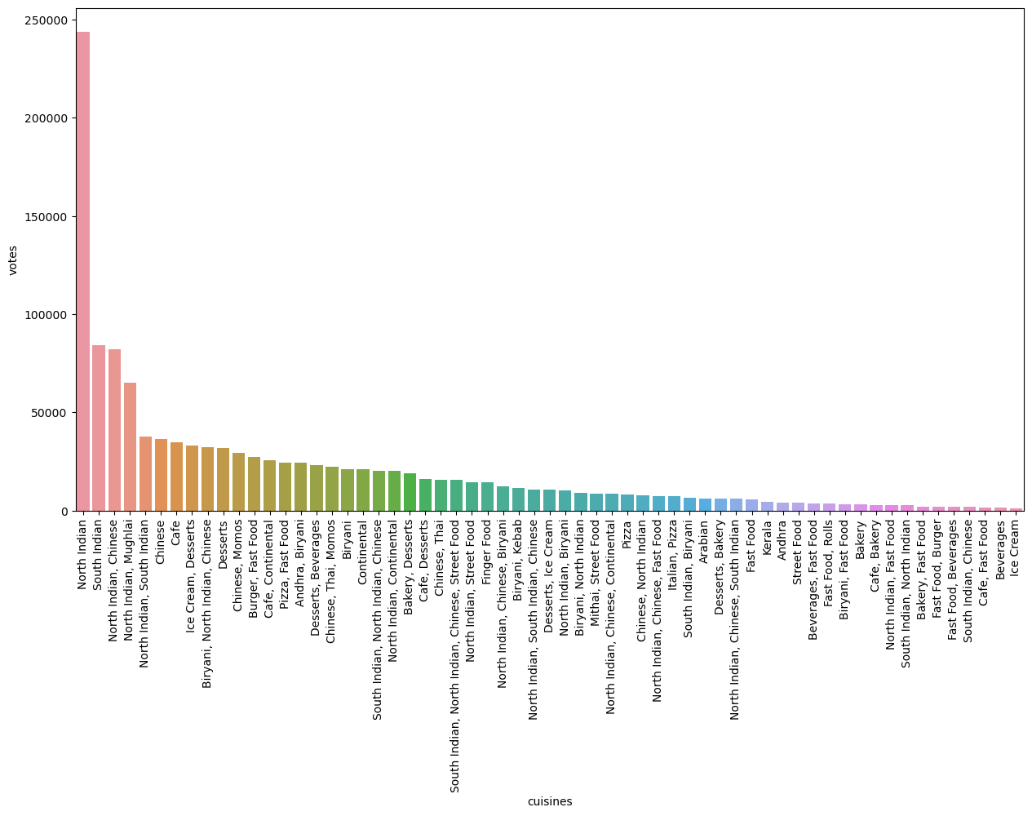

North Indian cuisine receives the maximum number of votes, followed by South Indian cuisine. North Indian and Chinese fusion cuisine comes in third place in terms of receiving votes. This indicates that North Indian cuisine is the most popular among the voters, followed closely by South Indian, with North Indian and Chinese fusion also being a favored choice among the customers.

Suggestions

Consider choosing locations like Old Airport Road or Shivaji Nagar for a new restaurant. These areas have fewer restaurants offering online orders, which could be an opportunity to stand out in the market.

Offering online order facilities is essential, as most restaurants already do. To stay competitive, make sure your restaurant provides this service.

Restaurants with a "book table" option tend to receive higher average ratings. Including this feature can enhance customer satisfaction and boost ratings for your restaurant.

When planning your restaurant's menu, prioritize North Indian cuisine, followed by South Indian and North Indian-Chinese fusion, as these are the most preferred cuisines among customers.

Pubs and bars receive higher average ratings, indicating their popularity. If you intend to open such an establishment, consider areas with fewer competitors in this category, like Shivaji Nagar and Shanti Nagar.